ATOMIC STRUCTURE
Atomic Theory of Dalton: (1805)
    - All matter is composed of tiny particles called atom which can not be created, destroyed or splitted.
    - All atoms of any one element are identical, have same mass and chemical properties.
    - A compound is a type of matter composed of atoms of two or more elements.
    - A chemical reaction consists of rearranging atoms from one combination to another.

Contribution: British Chemist John Dalton provided the basic theory: all matter- whether element, compound, or mixture- is composed of small particles called atoms.

Limitations: (1) Atom can be divided into subatomic particle namely electron, proton and neutron. (2) All atoms of any elements are not identical, have different mass and chemical properties. This property is known as isotopes.

Rutherford’s Model of Atom: (1909)
- Atom has a tiny dense center core or the NUCLEUS, which contains practically the entire mass of the atom, leaving rest of the atom almost empty.
- The entire positive charge of the atom is located on the nucleus, while electrons were distributed in vacant space around it.
- The electrons were moving in orbits or closed circular paths around the nucleus like planets around the sun.

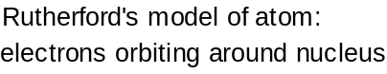

Weakness of the Rutherford Atomic Model:
- Newton’s Laws of motion and gravitation can only be applied to neutral bodies such as planets and not to charged bodies such as tiny electrons moving round a positive nucleus. The analogy does not hold good since the electrons in an atom repel one another, whereas planets attract each other because of gravitational forces. Besides, there is electrostatic attraction in a nuclear atom model.
- According to Maxwell’s theory, and charged body such as electrons rotating in an orbit must radiate energy continuously thereby losing kinetic energy. Hence the electron must gradually spiral in towards the nucleus. The radius of the electron will gradually decrease and it will ultimately fall into the nucleus, thus annihilating the atom model.
- Since the process of radiating energy would go on continuously, the atomic spectra should also be continuous and should not give sharp and well-defined lines.

Contribution: Rutherford laid the foundation of the model picture of atom.

Three subatomic particles or fundamental particles:

Atoms can be subdivided into smaller subatomic particles known as fundamental particles. They are: electron, proton and neutron.

Particle | Symbol | Mass |  | Charge (C)
Particle | Symbol | amu | kg | Units | Coulombs
Electron | e⁻ | 1/1835 | 9.10939×10⁻³¹ | -1 | -1.60218×10⁻¹⁹
Proton | p⁺ | 1 | 1.67262×10⁻²⁷ | +1 | +1.60218×10⁻¹⁹
Neutron | n or nº | 1 | 1.67493×10⁻²⁷ | 0 | 0

Atomic number, Mass Number & Isotopes

A proton is a nuclear particle having a positive charge equal to that of the electron and a mass more than 1800 times that of the electron. The atomic number is therefore the number of protons in the nucleus of an atom. The neutron is a nuclear particle having a mass almost identical to that of the proton but no electric charge. The mass number is the total number of protons and neutrons in a nucleus.

An atom is normally electrically neutral, so it has as many electrons about its nucleus as the nucleus has protons; that is, the number of electrons in a neutral atom equals its atomic number. All nuclei of the atoms of a particular element have the same atomic number, but the nuclei may have different mass numbers. Isotopes are atoms whose nuclei have the same atomic number but different mass numbers; that is, the nuclei have the same number of protons but different numbers of neutrons.

Quantum Theory and Bohr Atom: (1913)

To understand the Bohr theory, we need to learn the nature of electromagnetic radiations
and atomic spectra.

Electromagnetic Radiations:

Electromagnetic radiation can be described as a wave (carrier of energy) occurring simultaneously in electrical and magnetic fields and consists of particles called quanta or photons. Energy can be transmitted through space by electromagnetic radiations. Some forms of electromagnetic radiations are - radio waves, visible light, infrared light, ultraviolet light, X-rays etc.

These radiations have both the properties of a wave as well as a particle, now become familiar for their uses. The X-rays are used in medicine, the ultraviolet rays lead to sunburns and radio and radar waves used in communication and visible light.

Trough
Wave Length
Vibrating
Source
Energy
Crest
λ

Characteristics of Waves:
Wavelength (λ, lambda): The wavelength is defined as the distance between two successive crests or troughs of a wave.
Units: cm, m or Å (angstrom).
1 Å = 10⁻⁸ cm = 10⁻¹⁰ m, 1 nm = 10⁻⁹ m
Frequency (ν, nu): The frequency is defined as the number of complete cycles (oscillations) per second.
Units: hertz (hz), one cycle per second.
A wave of high frequency has a shorter wavelength, while a wave of low frequency has a longer wavelength.

Speed: The speed (or velocity) of a wave is the distance through which a particular wave travels in one second.
Speed = Frequency × Wavelength (c = ν × λ)

Wave Number: This is reciprocal of the wavelength and is given the symbol (nu bar).
= 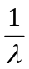

Problem-1: The wavelength of a violet light is 400 nm. Calculate its frequency and wave number. (c = 3 × 10⁸m sec⁻¹) (Answer: ν = 7.5 × 10¹⁴ sec⁻¹, = 25 × 10⁵ m⁻¹)

Problem-2: The frequency of strong yellow line in the spectrum of sodium is 5.0910¹⁴ sec⁻¹. Calculate the wavelength of the light in nanometers. (Answer: λ = 589 nm)

An increase in frequency or a decrease in wavelength represents an increase in energy.

Spectra: A spectrum is an arrangement of waves or particles spread out according to the increasing or decreasing of some property like wavelength or frequency.

Continuous Spectrum:

White light is radiant energy coming from the sun or from incandescent lamps. It is composed of light waves in the range 4000-8000 Å. When a beam of white light is passed through a prism, a continuous series of colour bands (rainbow: violet, indigo, blue, green, yellow, orange and red; VIBGYOR) is received on a screen with different wavelengths called Continuous Spectrum.

The violet component of the spectrum has shorter wavelengths (4000-4250Å) and higher frequencies. The red component has longer wavelengths (6500-7500Å) and lower frequencies. The invisible region beyond the violet is called ultraviolet region and the one below the red is called infrared region.
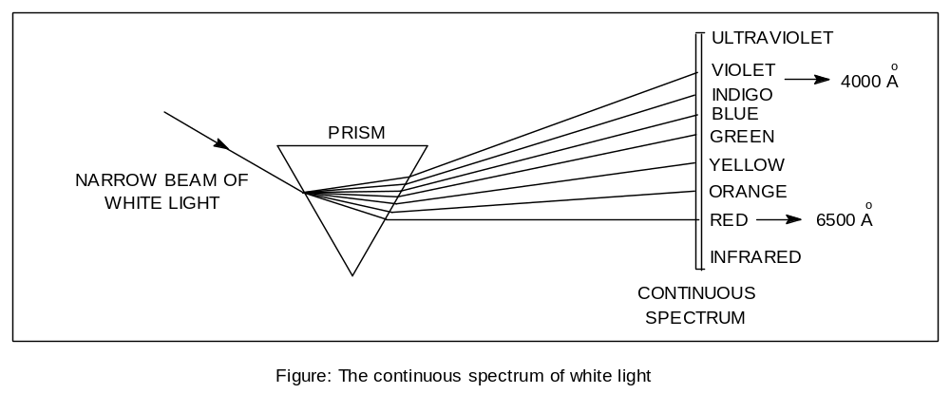

Atomic Spectra:

When an element in the vapor or the gaseous state is heated in a flame or a discharge tube, the atoms are excited and emit light radiations of a characteristic colour. The colour of light produced indicates the wavelength of the radiation emitted. The spectrum obtained on the photographic plate is found to consists of bright lines.

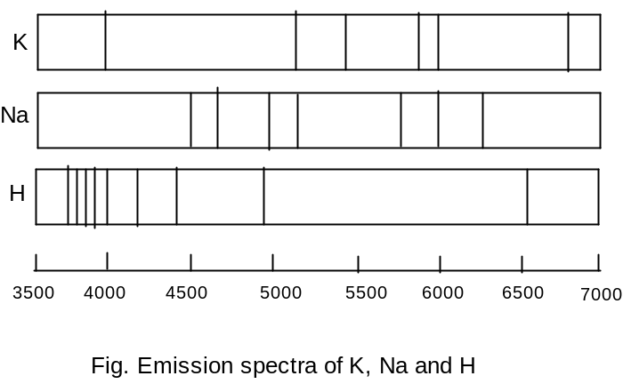

Atomic Spectrum of Hydrogen: Balmer Equation and Rydberg constant

The emission line spectrum of hydrogen can be obtained by passing electric through the gas contained in a discharge tube at low pressure. The light radiation emitted is then examined with the help of a spectroscope.

In 1884 J. J. Balmer observed the following four prominent coloured lines in the visible hydrogen spectrum:
- a red line with a wavelength of 6563 Å
- a blue-green line with a wavelength of 4861 Å
- a blue line with a wavelength of 4340 Å
- a violet line with a wavelength of 4102 Å

The above series of four lines in the visible spectrum of hydrogen is known as Balmer series.

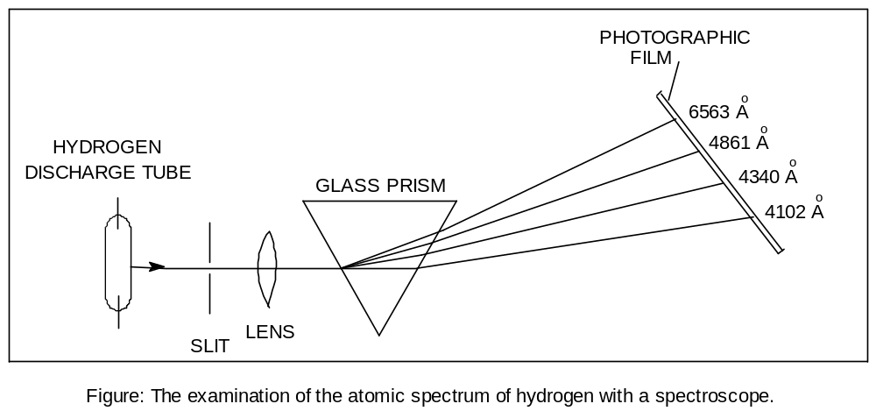

Balmer was able to give an equation which relate the wavelengh (λ) of the observed lines. The Balmer equation is,

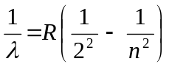

where R is a constant called Rydberg constant which has the value 109,677 cm⁻¹ and n = 3, 4, 5, 6, etc.

Five spectral series: In addition to Balmer series, four other spectral series were discovered in the infrared (ir) and ultraviolet (uv) regions of the hydrogen spectrum. These bear the names of discoverers.

- Lyman series (uv)
- Balmer series (visible)
- Paschen series (ir)
- Brackett series (ir)
- Pfund series (ir)

Quantum Theory of Radiation:

- When atoms or molecules absorb or emit radiant energy, they do so in separate ‘units of waves’ called quanta or photons.

Continuous
Wave

Photons or
quanta

individual photon

- The energy, E, of a quantum or photon is given by the relation.

E = hν (h, Planck’s constant = 6.62 × 10^{–27} erg sec. Or 6.62 × 10⁻³⁴ J sec.)
c = λν (c = velocity of radiation)
Therefore, E = 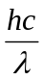

- An atom or molecule can emit (or absorb) either one quantum of energy (hν) or any whole number multiple of this unit.

Bohr Model of the Atom:

- Electrons travel around the nucleus in specific permitted circular orbits and in no others.

- While in these specific orbits, an electron does not radiate (or lose) energy.

- An electron can move from one energy level to another by quantum or photon jumps only.

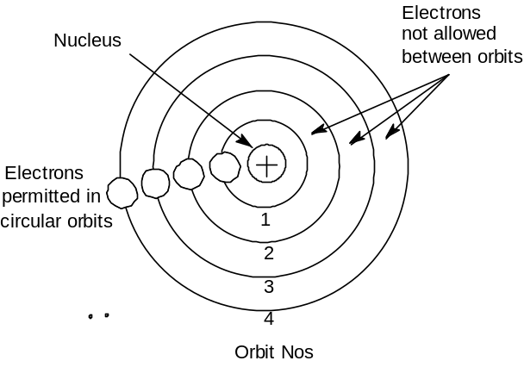

- The angular momentum (mvr) of an electron orbiting around the nucleus is an integral multiple of Planck’s constant divided by 2π.
i.e. Angular momentum = mvr = 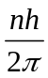,
where m = mass of electron, v = velocity of electron, r = radius of the orbit, n = 1, 2, 3…..etc and h = Planck’s constant.

Calculation of Radius of Orbits:

Consider an electron of charge e revolving around a nucleus of charge Ze, where Z is the atomic number and e the charge on a proton. Let m be the mass of the electron, r the radius of the orbit and v the tangential velocity of the revolving electron.

The electrostatic force of attraction between the nucleus and the electron (Coulomb’s Law),
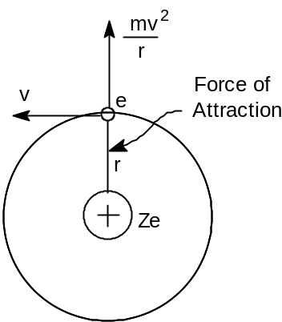

=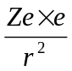

The centrifugal force acting on the electron

=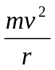

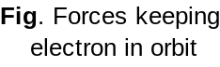

Bohr assumed that these two opposing forces must be balancing each other exactly to keep the electron in orbit. Thus,

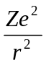=

For hydrogen Z=1, therefore,

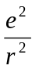=

Multiplying both sides by r
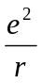= mv² --- --- --- (1)

According to Bohr’s theory, angular momentum of the revolving electron is given by the expression:
mvr = 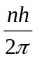
or v = 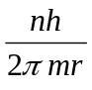 --- --- --- (2)

Substituting the value of v in equation (1)
= 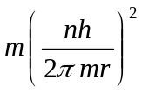
Solving for r,
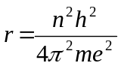 --- --- --- (3)

Since the value of h, m and e had been determined experimentally, substituting these values in (3), we have

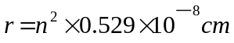 --- --- --- (4)

where n is the principal quantum number and hence the number of the orbit.

Problem-3: Calculate the first five Bohr radii of the hydrogen atom.

Problem-4: Calculate the radius of the third orbit of hydrogen atom.

Energy of Electron in each Orbit:

For hydrogen atom, the energy of the revolving electron, E is the sum of its kinetic energy 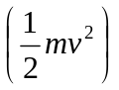 and potential energy 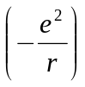. (Hints: P.E.=kq₁q₂/r; attractive force, so negative)

E = 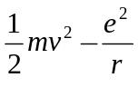 --- --- --- (5)
From equation (1)

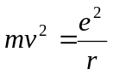

Substituting the value of mv² in (5),

E = 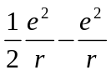
E = 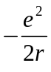 --- --- --- (6)

Substituting the value of r from equation (3) in (6),

E = 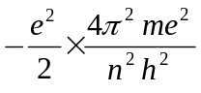= 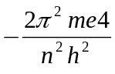 --- --- --- (7)

Substituting the values of m, e and h in (7),

E = 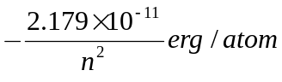,
or E = 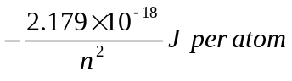 --- --- --- (8)

By using proper integer for n, we can get the energy for each orbit.

Problem-5: Calculate the five lowest energy levels of the hydrogen atom.

Problem-6: Calculate the energy of electron of the second orbit of the hydrogen atom.

Bohr Explanation of Hydrogen Spectrum:

- The solitary electron in hydrogen atom at ordinary temperature resides in the first orbit (n =1) and is in the lowest energy state (ground state).

- When energy is supplied to hydrogen gas in the discharge tube, the electron moves to higher energy levels viz., 2, 3, 4, 5, etc., depending on the quantity of energy absorbed.

- From these high energy levels, the electron returns by jumps to one or other lower energy level.

- In doing so the electron emits the excess energy as a photon.

- This gives an excellent explanation of the various spectral series of hydrogen.

Lyman series is obtained when the electron returns to the ground state i.e., n = 1 from higher levels (n₂ = 2, 3, 4, 5, etc.). Similarly, Balmer, Paschen, Brackett and Pfund series are produced when the electron returns to the second, third, fourth and fifth energy levels respectively as shown in Figure.

Table: Spectral series of hydrogen
Series | n₁ | n₂ | Region | Wavelength λ (Å)
Lyman | 1 | 2, 3, 4, 5, etc. | Ultraviolet | 920-1200
Balmer | 2 | 3, 4, 5, 6, etc. | Visible | 4000-6500
Paschen | 3 | 4, 5, 6, 7, etc. | Infrared | 9500-18750
Brackett | 4 | 5, 6, 7 | Infrared | 19450-40500
Pfund | 5 | 6, 7 | Infrared | 37800-75000

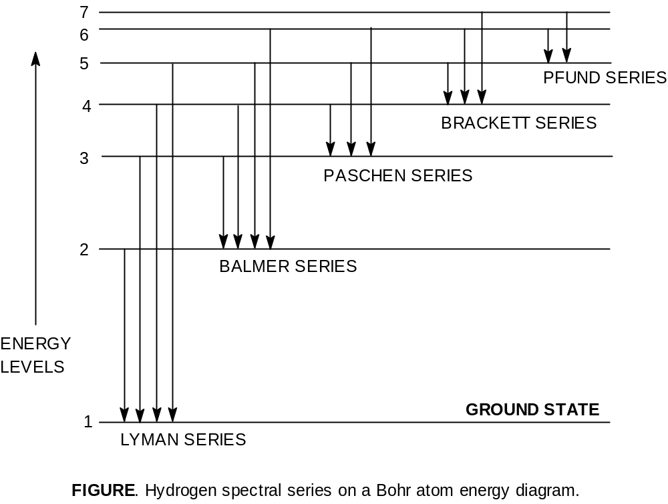

Values of Rydberg’s constant is the same as in the original empirical Balmer’s equation
According to equation (7), the energy of the electron in orbit n₁ (lower) and n₂ (higher) is:
E₁ = 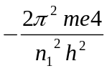
E₂ = 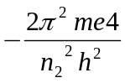
The difference of energy between the levels n₁ and n₂ is:
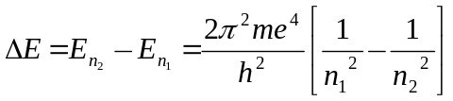 --- --- --- (9)
According to Planck’s equation
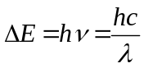 --- --- --- (10)
where is wavelength of photon and c is velocity of light. From equation (9) and (10), we can write

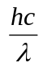 = 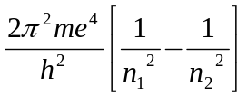

or, 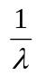 = 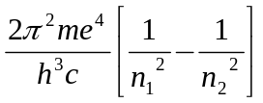

or, = 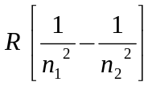 --- --- --- (11)

where R is Rydberg constant. The value of R can be calculated as the value of e, m, h and c are known. It comes out to be 109,679 cm⁻¹ and agrees closely with the value of Rydberg constant in the original empirical Balmer’s equation (109,677 cm⁻¹).

Calculation of wavelengths of the spectral lines of hydrogen in the visible region:

These lines constitute the Balmer series when n₁ = 2. Now the equation (11) above can be written as
= 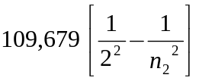
Thus the wavelengths of the photons emitted as the electron returns from energy levels 6, 5, 4 and 3 were calculated by Bohr. The calculated values corresponded exactly to the values of wavelengths of the spectral lines already known. This was, in fact, a great success of the Bohr atom.

Problem-7: Calculate the wavelength in Å of the line in Balmer series that is associated with drop of the electron from the fourth orbit. The value of Rydberg constant is 109,676 cm⁻¹.

Problem-8: Calculate the wavelength in Å of the third line in Balmer series that is associated with drop of the electron. (Rydberg constant =109,676 cm⁻¹).

Problem-9: The energy of the electron in the second and third orbits of the hydrogen atom is -5.42 ×10⁻¹² erg and -2.41×10⁻¹² erg respectively. Calculate the wave length of the emitted radiation when the electron drops from third to second orbit. (Answer: 6600Å)

Shortcoming of the Bohr Atom:
- It is unsuccessful for every other atom containing more than one electron,
- In view of modern advances, like dual nature of matter, uncertainty principle etc. any mechanical model of the atom stands rejected.
- Bohr’s model of electronic structure could not account for the ability of atoms to form molecules through chemical bonds.
- Bohr’s theory could not explain the effect of magnetic field (Zeeman effect) and electric field (Stark effect) on the spectra of atoms.

